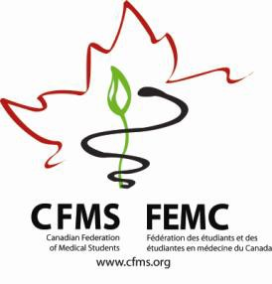**CFMS Spring General Meeting**

**Global Health Agenda**

Fairmont Hotel Vancouver

900 West Georgia Street

Vancouver, BC

|  |  |
| --- | --- |
| **Thursday, April 23, 2015** | |
| Global Health Program  *Waddington Room* | |
| 19:00 – 20:30 | **CFMS Executive Meeting**  CFMS Executive Only |
| 20:00 – 20:45 | Welcome and Introductions |
| 20:45 – 21:00 | **Vice-President’s Report** |
| 21:00 – 21:15 | *Break* |
| 21:15 – 22:45 | **National Officer Reports**  *(15 minutes each)*  NOGHE  NORSH  NOP  NEO  NOHRP  NAHL |
| 22:45 - 23:00 | *Overflow* |

|  |  |
| --- | --- |
| **Friday, April 24, 2015** | |
| CFMS Business Meeting  *Pacific Ballroom* | |
| Independent Breakfast and CCME Registration | |
| 8:30 – 9:00 | **CFMS Registration** |
| 8:00 – 8:15 | Introductions cntd. |
| 8:15 – 8:30 | **Transgender Health Policy Paper** |
| 8:30 – 8:45 | **Antimicrobial Stewardship Policy Paper** |
| 8:45 – 9:00 | **Humans of Pharmacare Launch** |
| 9:00 – 9:15 | *Break* |
| 9:15 – 9:30 | **Partner’s in Health Competition** |
| 9:30 – 9:45 | **Access our Medicines** |
| 9:45 – 10:00 | **IFMSA Discussion** |
| 10:00 – 16:30 | *Join CFMS Business Meeting* |
| 16:30 – 17:30 | **Global Health Brainstorming** |
| 17:30 – 18:00 | **Global Health Core Competencies**  *Golden Gao* |
| 18:00 – 18:30 | **NextGenU.org**  *Dr. Frank* |
| 18:30 – onwards | Q & A and Wrap-Up |